(Approx. 480 words)

Making Your Tech “Fit” – Cords, Voice, Sound, and other hazards
Author: Debra Carlson, Technical Advisor, CVC Computer Club, CO
Q4 2019 issue, Tech-Notes
cvc.computer.club (at) gmail.com

Cords – Whether tripping or kicking (and disconnecting) them …
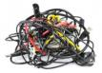
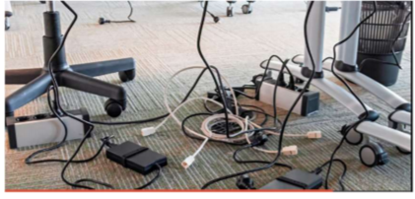
or getting the contents of your desktop lost in the shuffle …
cord / cable management is both a convenience and a safety issue.

Some basic principles:

- Label each Cord you plug into your outlets / surge devices.
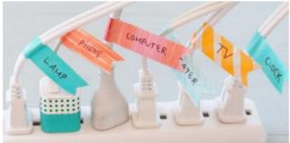

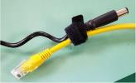
Hint: When you get a new device, unplug the power cord from the device and attach the outlet end of the new device to this with a twist tie (or tape). Pull the old cord from the outlet end and it will fish your new cable to the surge strip or outlet. This doesn’t work in a “mess of wires” but is good for many setups.
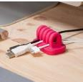
If you have many peripherals intermittently connected to your machine (a couple of cameras, a scanner, an external drive), consider a cable management “toy” for that as well.

Voice – You may have a microphone built into your webcam (or the webcam in your laptop), part of a headset, or a separate microphone. Settings are most often tested in an app that uses the microphone (e.g. Skype). External units may connect to your machine by audio jack, USB cable or Bluetooth (wireless). Two things are important:

1. Train transcription software completely if you use it. It will help minimize errors in the text.

2. If you are using this for dictation, assume there are going to be errors! Check for them … this will help avoid embarrassment over the messages you may send.

Sound – The biggest issues with speakers – USB, audio jack, Bluetooth, or Wi-Fi is accidental muting. This may happen on the speaker – especially if the on/off switch is a button rather than a knob control OR …
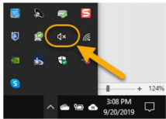

Your sound is muted (see the X next to, or on top of the megaphone)
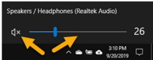

If not muted, the volume may be too low.

Your YouTube or other video may need either unmuting or volume adjustment (YouTube shown).

You may need to adjust the speaker volume AND the volume of the audio/video – setting both of them to maximum can interfere with sound clarity.

Other hazards –
- UPS units and surge/power strips can be great, but many have on/off switches. Be sure your unit is not in a position where it can be easily kicked (or hit) – and shut off.

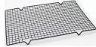
- All computing devices can overheat. Have circulation space -- at least a couple inches each side on a tower, and if you have a laptop that lies flush on a desk, consider a cooling pad or other prop (I like bread cooling racks – right height and size).

Old program CDs make good drink coasters, wind chimes, or decorative hangings / picture frames. A couple ideas to make your desk area manageable and clear some clutter.

